PERFORMANCE REPORT FOR THE YEAR ENDED 31 December 2019

New Zealand Rogaining Association Inc.
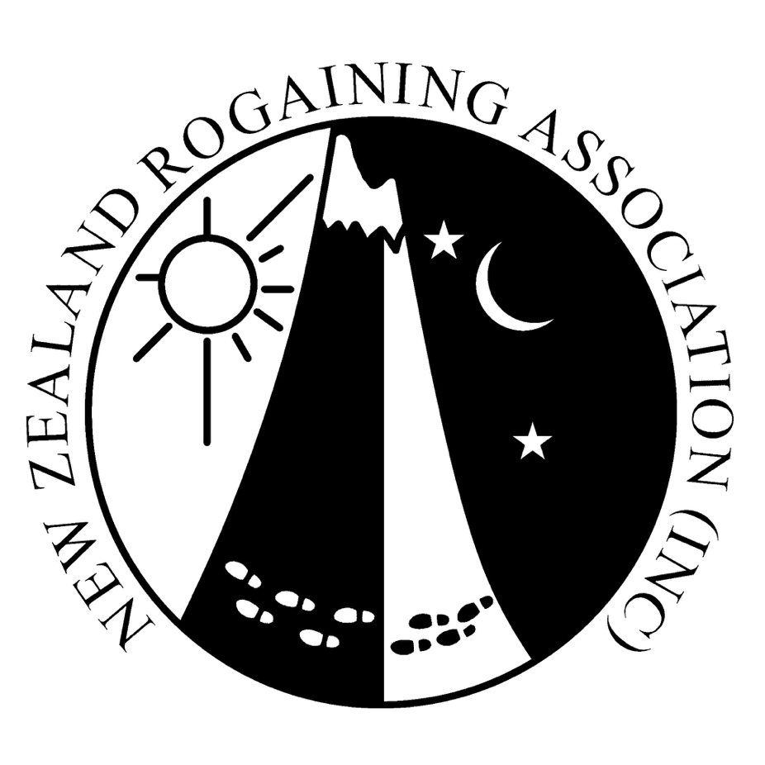

Contents
2 Entity information
4 Statement of receipts and payments
5 Statement of resources and commitments
6 Notes to the performance report
New Zealand Rogaine Association Inc. FOR THE YEAR ENDED 31 DECEMBER 2019

Association Information

Legal name of Association
New Zealand Rogaining Association Inc.

Type of entity and legal basis
New Zealand Rogaining Association is an incorporated society registered under the Incorporated Societies Act 1908.

New Zealand Rogaining Association (NZRA) Purpose
The NZRA exists to foster the development of Rogaining in New Zealand by:
- Organising Rogaines
- Advertising coming events
- Publishing event results and news items
- Providing assistance and a minimal cost-structure to any group who wants to organise an event

Association structure
New Zealand Rogaining Association is an incorporated society focused on supporting the development of Rogaining in New Zealand. Its operations are governed by its constitution that aligns with and supports the requirements in the Incorporated Societies Act 1908.

The Society is overseen by an ten-member board. The members of the governing body are as follows:
- Tim Farrant – President
- Reuben Scott – Treasurer
- Trevor Merrifield
- Nora Audra
- Alister Metherell
- Jamie Stewart
- Douglas Woods
- Wayne Millow
- Emma De Lacey
- Mat Bixley

New Zealand Rogaine Association Inc. FOR THE YEAR ENDED 31 DECEMBER 2019

Main sources of the entity’s cash and resources
NZRA’s primary source of funding is through the following:
- Association ran events
- Levies for Insurance and Navlight coverage

Description of the Association’s outcomes
2019 saw lots of great events – 44 in all sanctioned by NZRA. Events such as Heights of Winter were a sell out and the RAB NZ Rogaine Championships was a great success!

New Zealand Rogaine Association Inc. FOR THE YEAR ENDED DECEMBER 31 2019

Statement of receipts and payments

 |  | Actual this year | Actual last year
 | Notes | $ | $
Operating Receipts | 2
Event Revenue |  | $  $24,885.50 | $49,014.00
Other Revenue |  | $8,609.50 | $9,012.01
Total Operating Receipts |  | $33,495.88 | $58,026.01
Operating Payments | 3
Payments Related to Events |  | $3,760.79 | $13,192.32
Fundraising/Donations Paid |  | $19,254.00 | $30,717.01
Other Operating Payments |  | $2,368.47 | $3,933.49
Operating Surplus/Deficit |  | $8,197.99 | $10,183.19
Capital Receipts | 2
Receipts from borrowings |  | $0.00 | $0.00
Total Capital Receipts |  | $0.00 | $0.00
Capital Payments
Repayments of borrowings |  | $0.00 | $0.00
Purchase of Resources |  | $0.00 | $607.95
Total Capital Payments |  | $0.00 | $607.95
Increase/Decrease in Funds Available |  | $8,197.99 | $9,575.24
Funds at the Start of the Financial Year |  | $85,675.75 | $76,100.51
Funds at the End of the Financial Year |  | $93,873.74 | $85,675.75
Represented By:
Cheque Account |  | $36,418.86 | $29,448.49
Term Deposit Accounts |  | $57,454.88 | $56,227.26
Total Funds at the End of the Financial Year |  | $93,873.74 | $85,675.75

This financial statement should be read in conjunction with the accompanying notes on pages 6-7.

New Zealand Rogaine Association Inc. FOR THE YEAR ENDED DECEMBER 31 2019

Statement of resources and

commitments

 | This year
 | $
Schedule of Resources
Bank Accounts and Cash | $36,418.86
Other Resources
Term Deposit | $57,454.88
PLB Unit | $876.57
Loud Hailer | $1,346.00
Total Resources | $96,096.31
Schedule of Commitments
The association has no commitments currently.

This financial statement should be read in conjunction with the accompanying notes on pages 6-7
New Zealand Rogaine Association Inc. FOR THE YEAR ENDED DECEMBER 31 2018

Notes to the performance report

1. Accounting policies

Basis of preparation
The New Zealand Rogaine Association Inc. is permitted by law to apply PBE SFR-C (NFP) Public Benefit Entity Simple Format Reporting - Cash (Not-For-Profit) as established by the External Reporting Board for registered Associations and has elected to do so.

All transactions are reported in the Statement of Receipts and Payments and related Notes to the Performance Report on a cash basis.

Goods and services tax (GST)
The New Zealand Rogaine Association is not registered for GST. Therefore, all amounts recorded in the Performance Report are exclusive of GST.

2. Analysis of receipts

Fees
Entry Fees |  | $25,630.50
Less Entry Fee Refund |  | ($745.00)
Total |  | $24,885.50
Other Revenue
NavLight Income |  | $3,561.20
Levies |  | $3,800.80
Acc 01 Interest (Cheque Account) |  | $19.88
Acc 03 Interest |  | $1,227.62
Total |  | $8,609.50

New Zealand Rogaine Association Inc. FOR THE YEAR ENDED DECEMBER 31 2018

3. Analysis of payments

Payments Related to Events
Consumables |  | $707.25
Mapping |  | $1,479.76
Prizes/Trophies/Engraving |  | $100.00
Mileage Reimbursement |  | $1,472.78
Total |  | $3,760.79
Fundraising/Donations Paid
HOW Donation |  | $19,254.00
Total |  | $19,254.00

Other Operating Payments
Bank Fees |  | $121.33
Open Host Web Site |  | $254.00
Accountancy Expenses |  | $326.89
Insurance |  | $1,495.00
Federation Levies |  | $85.00
Total |  | $2,282.22

